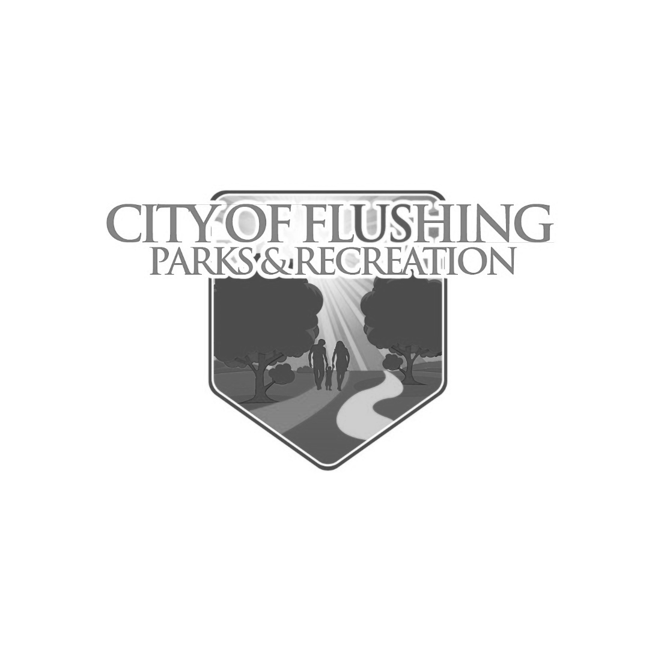
Farmers Market Application
City of Flushing Parks and Recreation
Name/Business:_____________________________________________________________________
Address:____________________________________________________________________________
City/State/Zip:_______________________________________________________________________
Phone:___________________________Email:_____________________________________________
Fees: Applying as:
___ $10 Resident Farm table ___ Produce Vendor
___ $25 Non-Resident Farm table ___ Baker
___ $25 Craft/Other table* ___ Handmade items
___ $10 to rent a table for use at your space ___ Other
*Read below for details on vendor space *
___ Seasonal Resident Farm table $125 (All 15 Market Days)
___ Seasonal Non-Resident/Other table $350 (All 15 Market Days)
___ Electric requested, this will be first come- first served and is not guaranteed
Please note that the market is open rain or shine.
The market is held on the concrete pad next to the parking lot of Riverview Park on South Cherry Street in Flushing MI, 48433
A limited number of tables will be available for rent on a daily basis.
Payment must be made at least one week prior to the day of the Market to reserve a spot, and all forms turned in at that time unless they are already on file for the season. Checks can be made payable to the City of Flushing. Venmo is also available for payment upon request.
Vendor Responsibilities:
Vendors are responsible for their own tables, chairs and necessary equipment.
Vendors must comply with all applicable health and safety regulations
Vendors must set up their booths between 8-9 AM and tear down by 3 PM
Vendors must keep their area clean and family friendly. No debris can be left on site after 3 PM
Cancellation Policy:
Vendors must cancel their reserved Saturday space by the preceding Wednesday in order to transfer their fee to another date or have it refunded. If the Cancellation is made after Wednesday, the fee will be forfeited. More than two cancellations per season may result in forfeiting future privilege to participate in the Flushing Farmers Market
No refunds will be given for no-shows due to rain. If the market is cancelled by the market manager due to inclement weather (lightning, flooding, tornado) the table fee for that day can be transferred to another day, but will not be refunded.
Vendor Details:
All items sold at the market must be locally grown or handmade. Vendor space is not available for Religious or political purposes. All “Other” vendor approvals are at the discretion of the market manager and Farmer’s market sub-committee
Vendors Spaces are approximately 12’ by 12’, no tents or shade will be provided, and vendors are required to have weights on tent legs, no stakes can be used to hold tents down.
Product Declaration:
Farmer/Grower: Fruits, Vegetables, Plants, Flowers
Please describe the products you intend to bring to the market. Indicate where items are grown and specify whether any items are certified organic.
____________________________________________________________________________________________________________________________________________________________________________________________________________________________________________________________________________________________________________________________________________________________________________________________________
Cottage Food: Qualified foods prepared in a home kitchen.
Please describe the products you intend to bring to the market. All products must comply with packaging and labeling requirements of the Michigan Cottage Food Law. Visit www.michigan.gov/cottagefood for more information
____________________________________________________________________________________________________________________________________________________________________________________________________________________________________________________________________________________________________________________________________________________________________________________________________
Honey/Eggs/ Maple Syrup, and Cider Vendors:
Please describe the products you intend to bring to the market.
____________________________________________________________________________________________________________________________________________________________________________________________________________________________________________________________________________________________________________________________________________________________________________________________________
Artist/Crafter:
Please describe the products you intend to bring to the market. All items must be handmade and sold by the artist, or other wise approved by the market manager. Please describe the items that you intend to sell. Photos may be requested.
____________________________________________________________________________________________________________________________________________________________________________________________________________________________________________________________________________________________________________________________________________________________________________________________________
Indemnity Agreement:
I have read and agree to abide by all rules, policies, and federal, state, and local laws, codes and regulations. I agree to cooperate with Market management. I will secure all licenses needed for the sale and distribution of products that require them, and I will supply a copy of such licenses as part of this application. I agree to indemnify and hold harmless any volunteers or employees of the city of Flushing and Flushing Parks and Recreation from all liability, claims, demands, losses, damages, levies, and causes of action or suits of any nature related to my activities at the Flushing Farmer’s Market.
I will secure and provide a certificate of Liability insurance listing Flushing Farmer’s Market with all applicable dates
I have received a copy of the rules and policies for the Flushing Farmer’s Market. I understand that it is my responsibility to ensure that all my employees read and follow the rules and policies. The information I have provided is correct and complete to the best of my knowledge. I agree to be bound by all market rules and policies set forth by the Flushing Farmer’s Market. I agree not to sell flea market-type items or other items not produced personally by me. I understand that my privilege to participate in the Flushing Farmer’s Market may be revoked at any time for any reason.

May | June | July | August
3 | 7 | Closed | 2
10 | 14 | 12 | 9
17 | Closed | 19 | 16
Closed | 28 | 26 | 23
31 |  |  | 30
Completed applications can be emailed, dropped of at the City Offices or mailed to:
City of Flushing Market Hours 9AM to 2 PM
Attn: Parks and Recreation
725 E Main Street
Flushing MI 48433
Agreement:
By signing below, the vendor acknowledges that they have read, understand and agree to the terms and conditions outlined in the contract.

Name:___________________________________Date: ______________Business Name:_____________________

